### Day 5- 108415746-Srilekha Bhimavarapu

**Linux commands:**

Create a Directory with the Name Linux Practice.

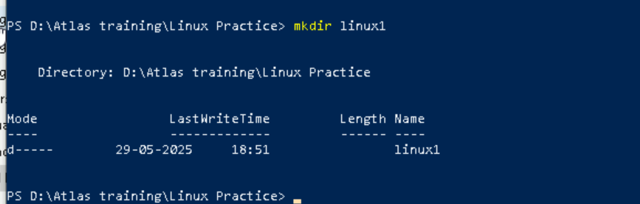

Create a file name TestFile1.txt and add the content to it.

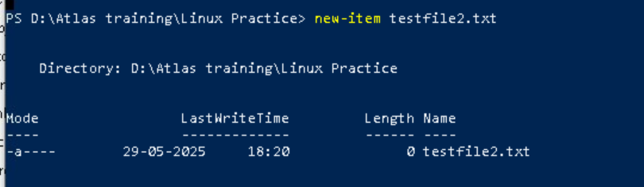

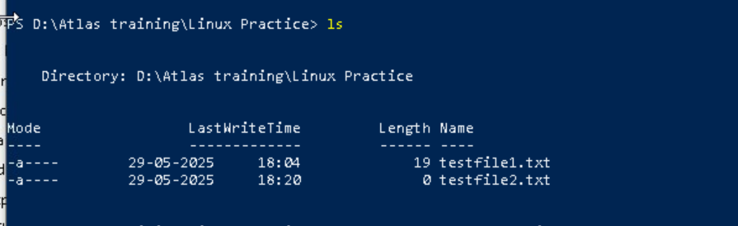

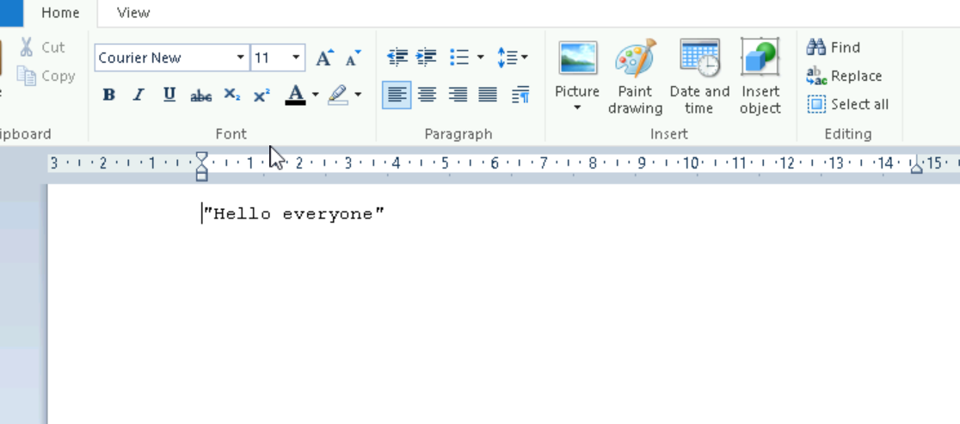

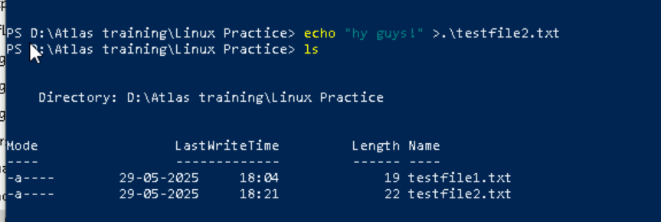

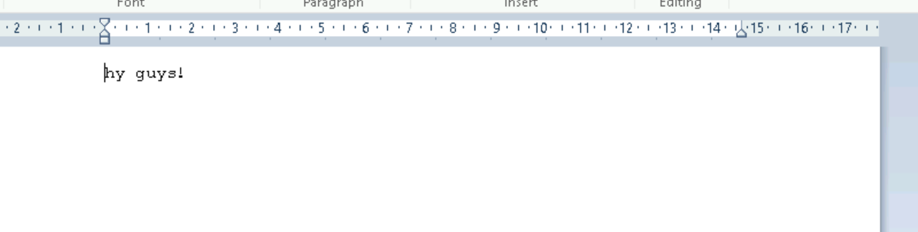

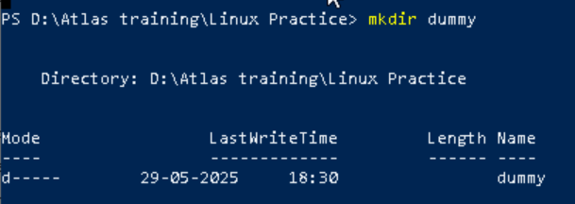

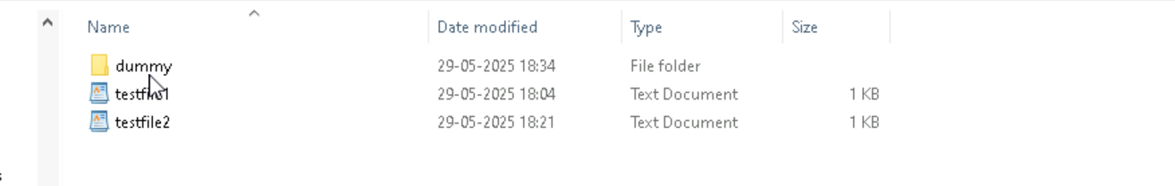

rmdir will remove the directory where as rm will remove the file.



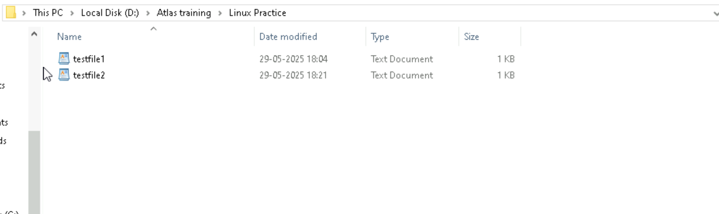

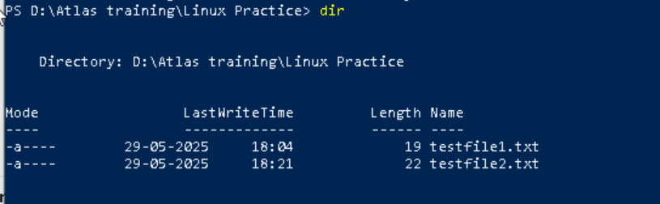

Create five files named TestFile2.txt.. TestFile3.txt… and so on till TestFile6.txt

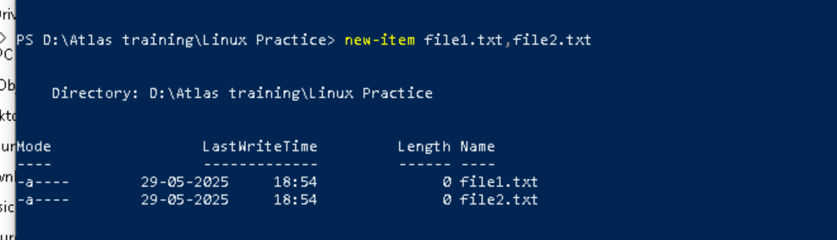

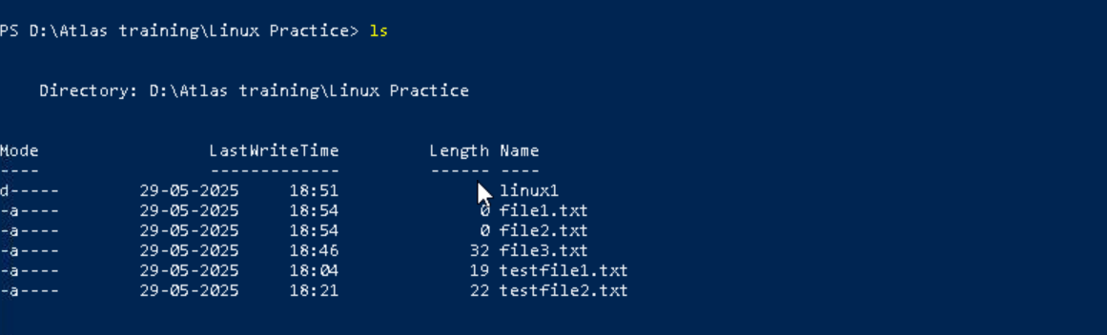

Move all files from Dir 2 to Dir 3

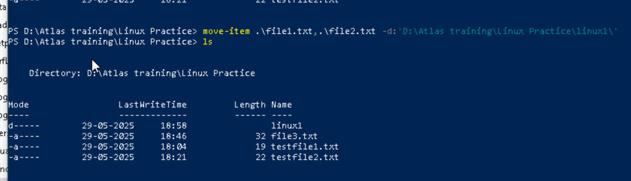

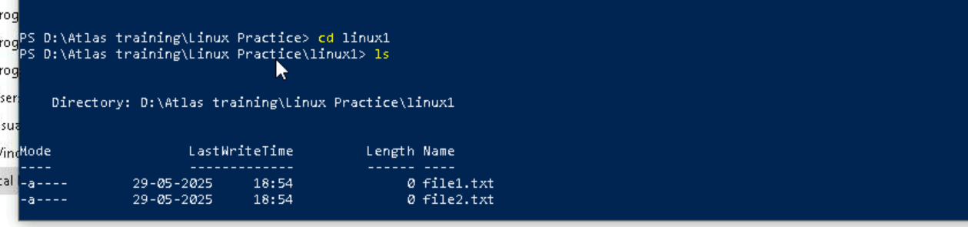

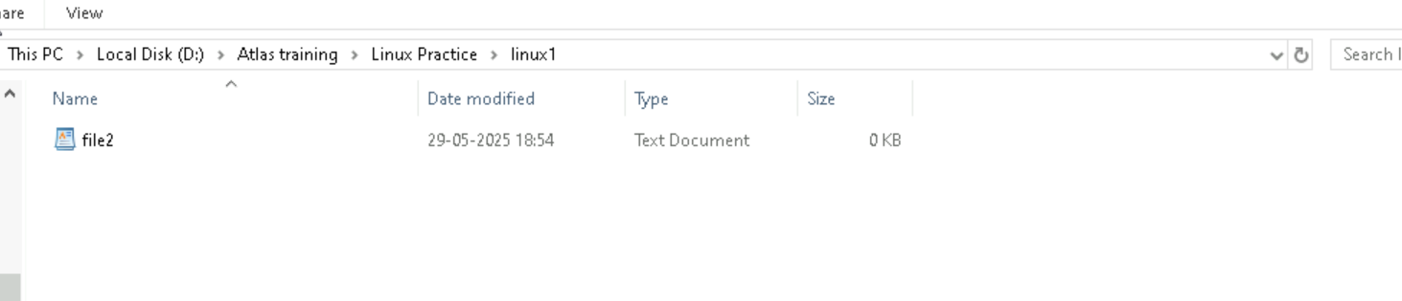



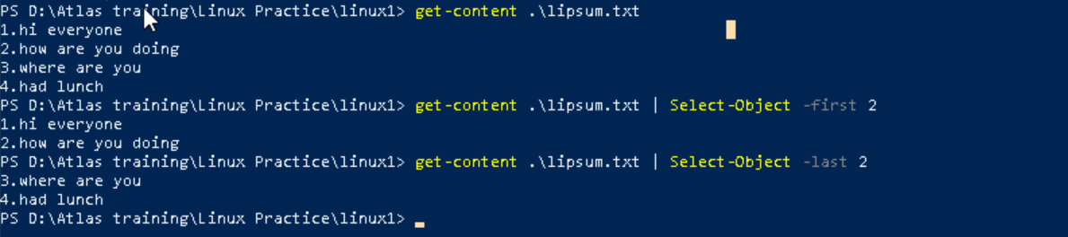

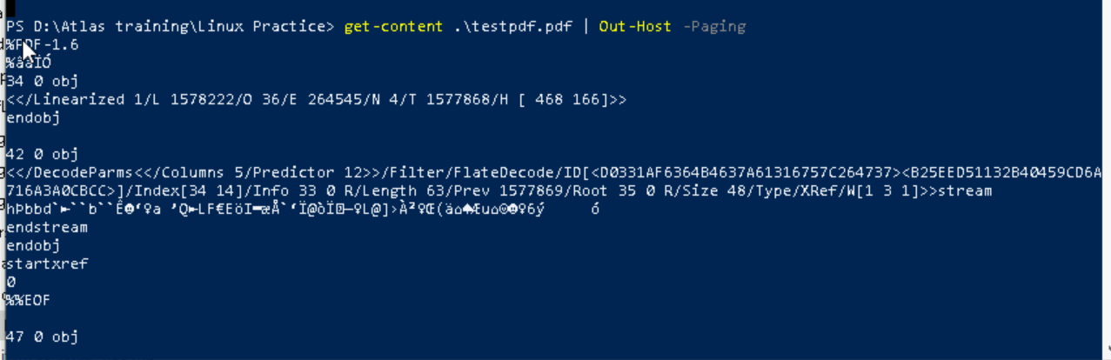

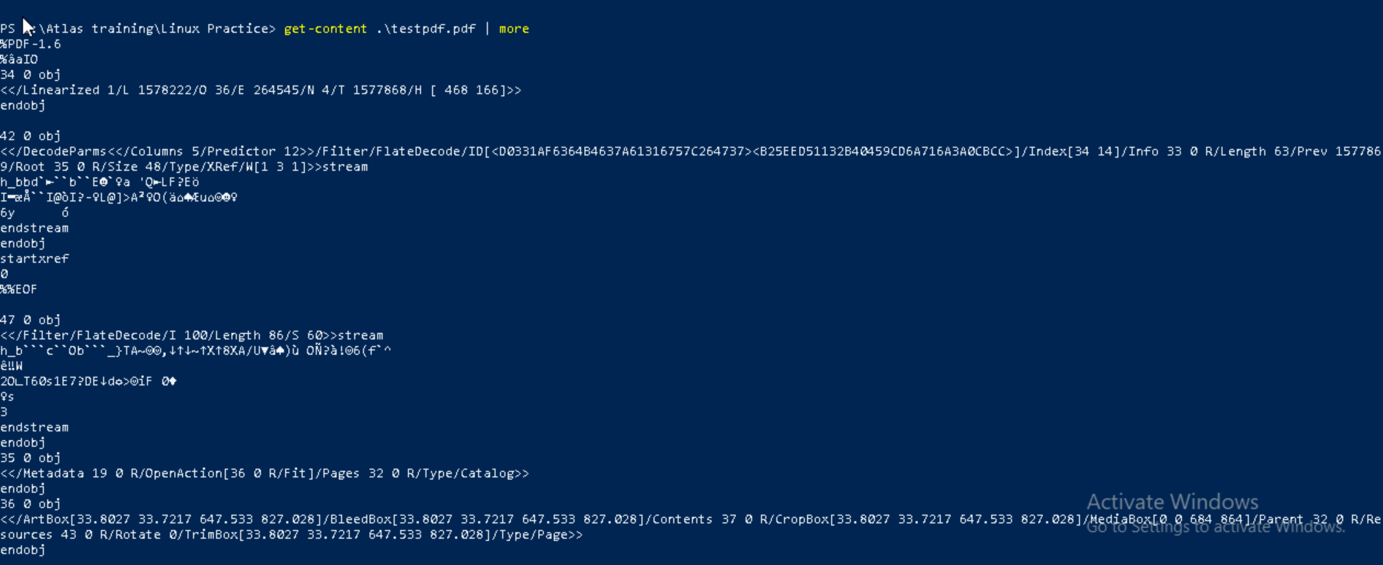

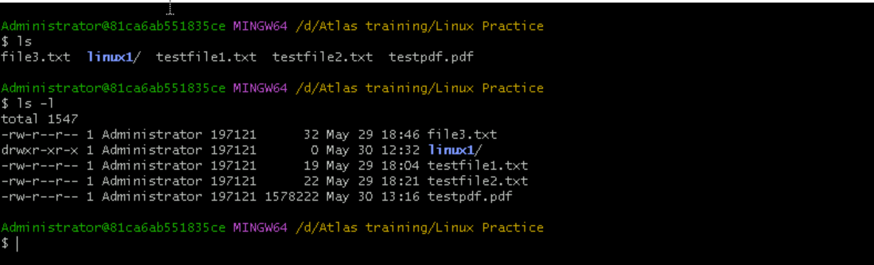

To change from one directory to another one will use cd.. command

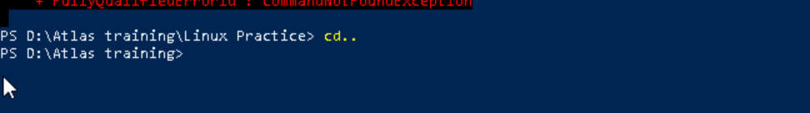

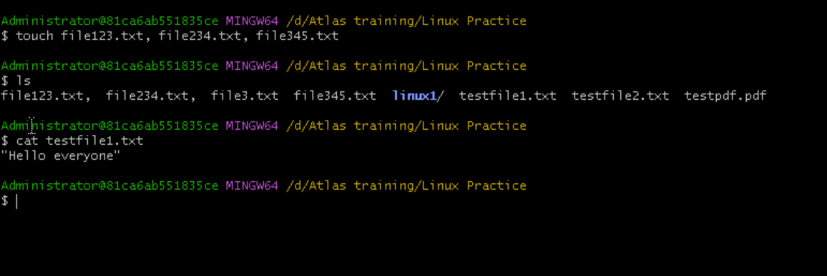

Touch command will create the files where as when we use cat command then it’ll show the message written in that file too. Echo command displays text or strings to the terminal screen.

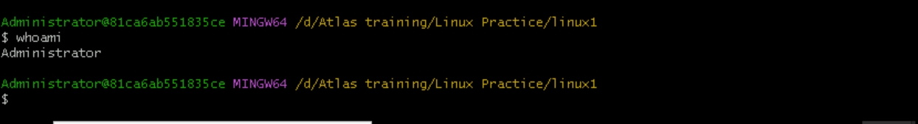

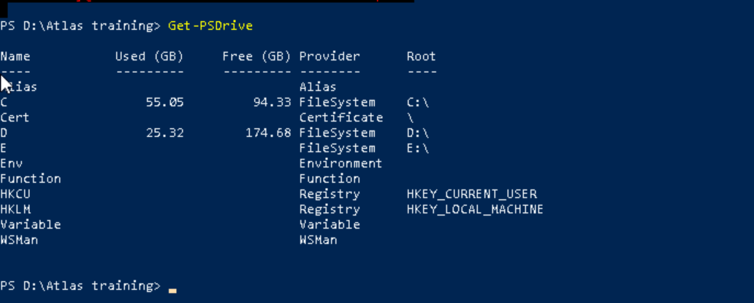

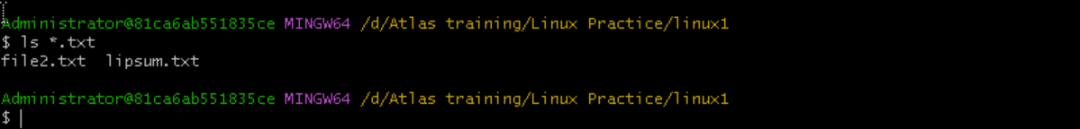

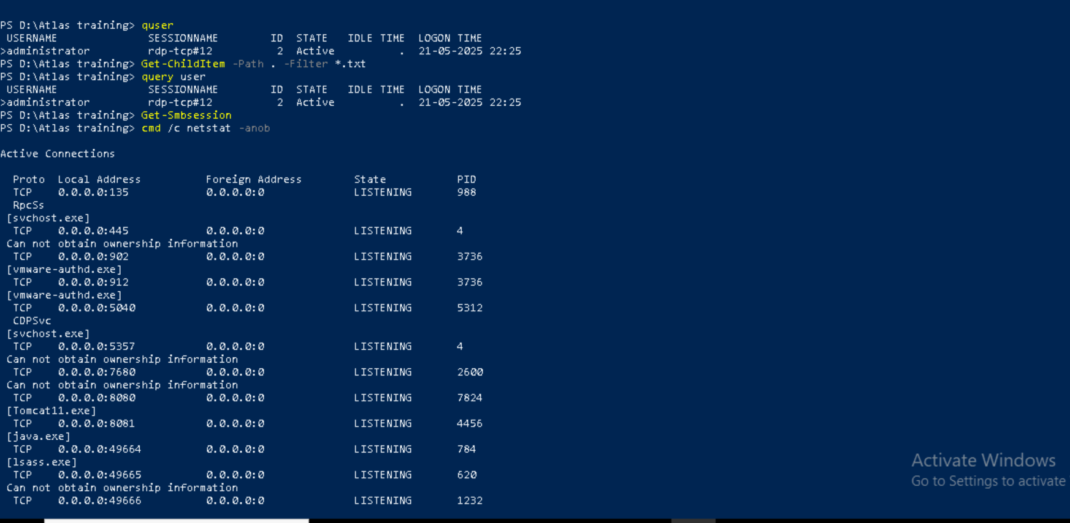

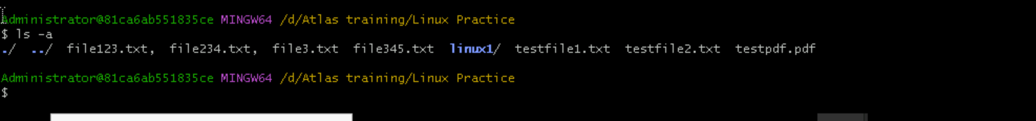

Single dot refers to the current working directory   
double dot refers to the parent directory (one level up in the directory hierarchy)

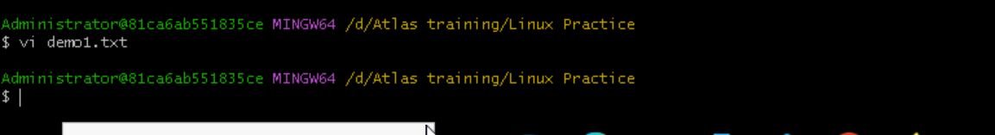

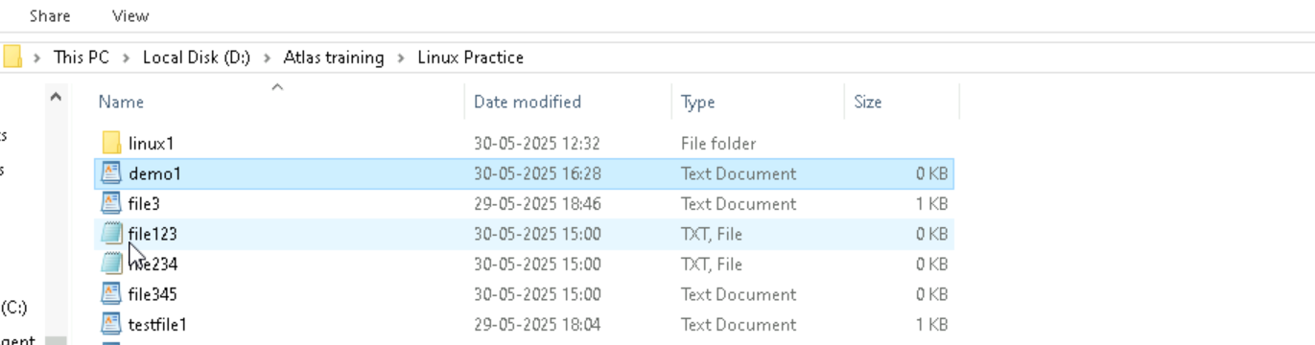

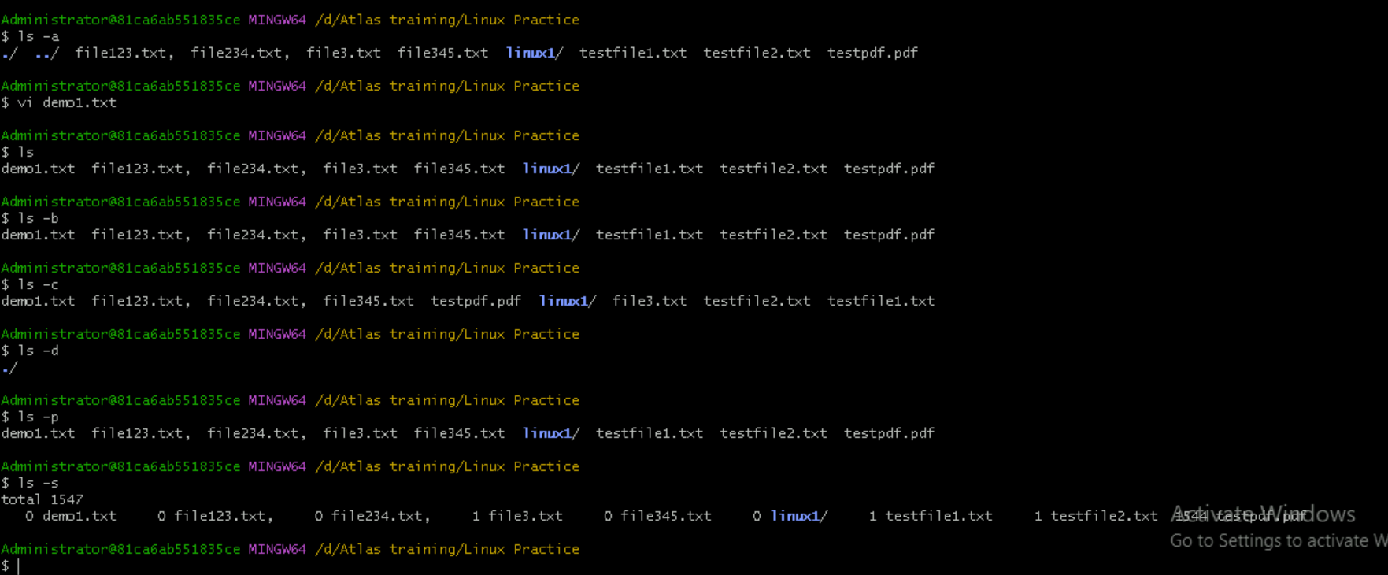

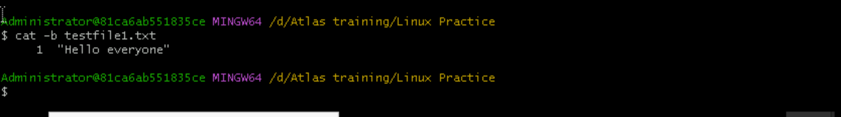

Used to display the contents of a file.

